Introduction 3

Mixed and Virtual Reality Display Technologies 5

Head-Worn Displays 5

Handheld Displays 8

Projector Based Displays 9

Cave Automatic Virtual Environments (CAVES) 10

Calibration and Registration 11

Mixed and Virtual Reality Visualizations 14

Diagnostics and Exploration 15

Intervention and Clinical 22

Interactions and Gestures 32

Education 36

Conclusion 40

References 41

Mixed and Virtual Reality Interaction and Presentation Techniques for Medical Visualizations

Ross T. Smith1,2, Thomas J. Clarke1,2, Wolfgang Mayer3, Andrew Cunningham1,2, Brandon Matthews1,2, Joanne E. Zucco1,2

**Keywords:** Mixed Augmented and Virtual Reality, Medical Visualization, Presentation Techniques

[Ross.smith@unisa.edu.au](mailto:Ross.smith@unisa.edu.au), [thomas.clarke@mymail.unisa.edu.au](mailto:thomas.clarke@mymail.unisa.edu.au), [wolfgang.mayer@unisa.edu.au](mailto:wolfgang.mayer@unisa.edu.au), [brandon.matthews@unisa.edu.au](mailto:brandon.matthews@unisa.edu.au), [jo.zucco@unisa.edu.au](mailto:jo.zucco@unisa.edu.au)

1: IVE: Australian Research Centre for Interactive and Virtual Environments

2: Wearable Computer Laboratory

3: AI and Software Engineering Laboratory

**Abstract**

Mixed, Augmented and Virtual reality technologies are burgeoning with new applications and use cases appearing rapidly. This chapter provides a brief overview of the fundamental display presentation methods; head-worn, hand-held and projector-based displays. We present a summary of visualization methods that employ these technologies in the medical domain. A diverse range of examples are presented including diagnostic and exploration, intervention and clinical, interaction and gestures, and education.

# Introduction

Immersive technologies such as mixed and virtual reality provide a method of interacting with 3D data that is perceived differently compared to traditional desktop displays. These technologies provide spatial experiences and interactions that go well beyond those available on flat screens with mouse and keyboard interaction. Immersive technologies enable the user to freely explore virtual information by means of zooming, changing viewpoint, highlighting important aspects while hiding others, and interacting with the virtual world in ways that would be impossible to achieve in the real world. Some techniques even enable users to walk around in the virtual environment as if it were real. For example, a virtual human can be presented in a 1:1 scale and appear to be sitting at an office desk, unlike a desktop display where the virtual human always appears inside the computer. One area these technologies have focused on is delivering immersive and interactive experiences that allow users to move freely around 3D environments to deliver compelling visualizations. There are a diverse set of visualizations that are being developed in the medical domain, from x-ray vision techniques that allow users to peek inside the human body to abstract data representations that support planning of procedures or analysis of scan data.

This chapter provides an overview of emerging visualizations that are employing interactive presentation methods as an adjunct for current medical processes. A summary of hardware technologies used to deliver Mixed Reality (MR) and Virtual Reality (VR) experiences and the importance of calibration for medical applications is discussed. Preceding this, we describe several aspects of mixed reality visualizations with exemplars around diagnostic and exploration, interventional and clinical, interaction and gestures and educational examples.

# Mixed and Virtual Reality Display Technologies

A diverse set of hardware technologies are currently available that allow the presentation of immersive Virtual and Mixed reality content to be experienced. This section provides a brief overview of major hardware categories, examples of hardware devices and pros and cons of each. Commonly identified categories include head-worn, hand-held and projector-based displays for presenting mixed and virtual reality environments. For each of these technologies we use the term Mixed Reality and Augmented Reality interchangeably to indicate computer generated content registered to the physical world.

## Head-Worn Displays

Head-worn displays offer a means of presenting mixed or virtual reality content suitable for medical visualizations, training, step-by-step guidance and many other applications. The first virtual reality system used a head-worn display developed by Ivan Sutherland in 1968 (Sutherland, 1968). There have been ongoing improvements in the quality, form factor, resolution and capability of these devices. Early displays, such as the Sony Glasstron which was released in 1996 provided an augmented reality display solution typically connecting to a desktop computer. However, more recent, complete systems incorporate several sensors to support standalone operation or wireless transmission of data thus dispensing with the need for cable attachments. The Microsoft HoloLens (shown in 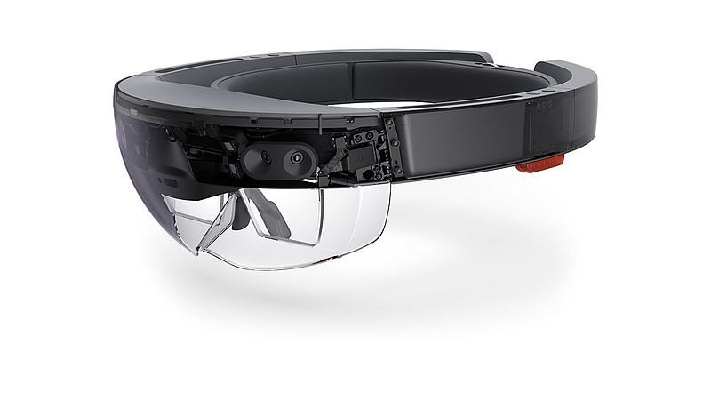Figure 1) was first shipped in 2016 and is a good example of a stand-alone computer integrated with a display device to provide a complete mixed reality solution to deliver holographic images that are aligned (or registered) in the physical world (Figure 2). The HoloLens includes spatial mapping, gesture and speech recognition. Currently, there are several commercially available mixed reality displays including the Meta, Magic Leap One and the recently announced the HoloLens 2 with improved features such as wider viewing area, object tracking and automatic calibration.

Figure 1 - Microsoft HoloLens mixed reality device

Virtual Reality displays are available in many form factors and are accompanied with supporting technologies such as position tracking, front facing camera, eye tracking, EEG sensors, hand controllers and more to deliver compelling virtual experiences. Desktop systems such as the Oculus Rift S and HTC Vive Pro offer high quality display systems that delivery immersive 3D environments coupled with a high-end PC equipped with graphics acceleration. They also incorporate tracking systems that enable the detection of the position of hand controllers that support hand-based interactions in virtual worlds. Standalone hardware options such as the Oculus Quest and Vive Focus have also become available which remove the necessity to be tethered to a PC and allow for wide area virtual environments to be configured.

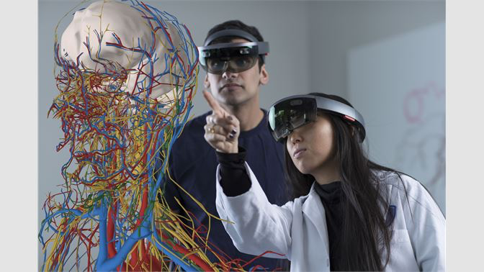

Figure 2 – Microsoft Hololens with collaborative anatomy visualization (HoloAnatomy)

One of the advantages of head-worn displays is that they leave the operators’ hands free to perform other tasks, unlike hand-held technologies, such as smartphones, which require the user to hold the device during operation.

## Handheld Displays

Modern smartphones and tablets provide a suitable platform for presenting video see through mixed reality experiences that use the smartphones camera to capture the physical world which is augmented with digital content (shown in Figure 3). The wide availability of smartphones has also made them a popular choice for mixed reality experiences. One advantage of this approach is the brightness of the display often outperforms head-worn displays that can appear washed out. In comparison to head-worn displays smartphones need to be held by the user or require a stand to hold during operation. A use case that has been increasing in popularity is for training or education applications where 3D content is presented as an adjunct to a paper based medium. Figure 3 provides an example that can be viewed from any angle using a smartphone as a hand-held viewing window into rich 3D content.

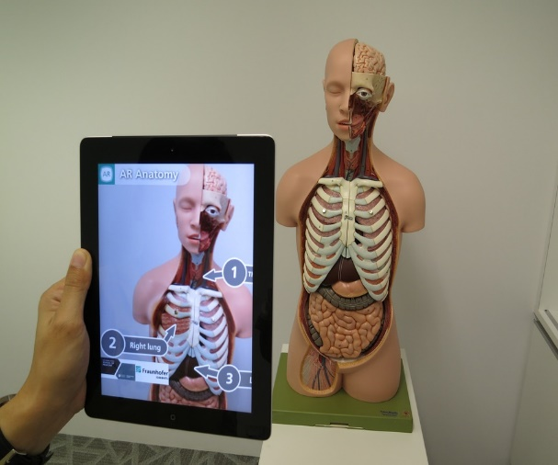

Figure 3 - Smartphone mixed reality

## Projector Based Displays

Projector based mixed reality systems, also known as Spatial Augmented Reality, employ projectors to alter the appearance of physical objects that can be highly organic in shape instead of a typical projector screen. This form of augmented reality has received less attention compared to head-worn and hand-held solutions. However, projected information provides some unique features that have potential for several applications. An advantage of projected information overlaid on physical objects is that multiple observers can perceived the same projection simultaneously and from multiple points of view. For example, visualisations of internal anatomical details directly projected onto the human body can collaboratively been viewed by a group of people but does not require individuals to wear or hold equipment on their bodies (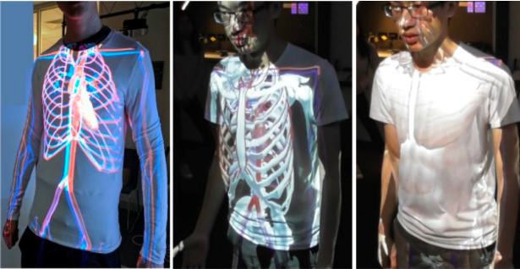

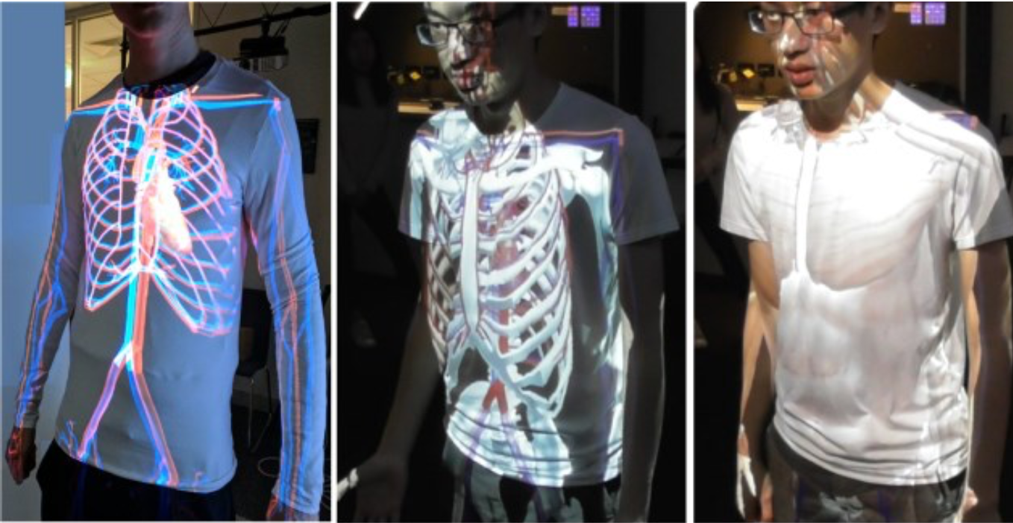

Figure 4 - Projector based muscle visualization on human body

Figure 4).

## Cave Automatic Virtual Environments (CAVES)

Cave environments are another instance of spatial augmented reality technology. Caves are three dimensional cubicles that use several projected images to simulate an immersive 3D environment without users needing to wear a headset. As such, caves can provide a collaborative AR experience for one or more medical professionals who wish to (collaboratively) explore vast amounts of information.

For example, medical data can be visualised in the form of three-dimensional models that can be viewed collaboratively in a cave environment for diagnosis (Knodel et al., 2018). Digital Imaging and communications in medicine (DICOM) files were processed into 3D models using an algorithm that converts voxels to polygons that are refined into visualizations to be viewed using 3D glasses in a collaborative environment.

## Calibration and Registration

Augmented reality techniques rely on computer generated content to be overlaid on real world physical objects. The user experience in such settings critically depends on accurate and precise registration (or alignment) between the visualisation of the virtual content and the physical objects. For head-mounted and see-through devices, this also includes the accurate estimation of the user’s and the device’s position and orientation in the physical and virtual worlds. Alignment must be established and maintained throughout the user’s interaction with the augmented world using registration techniques. This section presents several calibration methods that aim to improve registration performance. Calibration includes how multiple hardware systems operate together such as a camera and projector pair need to operate in a common coordinate space while registration is the alignment between the physical and virtual information.

Registration between the two spaces has received ongoing attention to create a reliable and precise alignment between the physical and digital information. Registration techniques can rely on markers whose positions in both spaces are known (Cutolo, 2016). Techniques also exist that make use of sensing and computer vision methods to infer the location and orientation of key objects in physical space that are also present in the virtual world for alignment purposes (Hoe et al, 2019). The precision of sensing and vision technologies as well as latency introduced by computational complexity of the underlying algorithms pose challenges for maintaining precision alignments.

In the medical domain, precise registration may not be required for some tasks, for example when adding annotations such as the temperature of the skin over a person's forehead, a little jitter or movement may not have a big impact on the function. Precise registration is important for some medical applications, for example, a MR system used to support or guide operations for a surgery. In such cases, the calibration and registration are both important parameters to ensure a positive outcome.

The number of markers required for precise registration can be reduced if high resolution sensors are utilised. Cutolo et al. (Cutolo et al., 2016). explored the use of high-resolution cameras for this purpose. In their system two cameras tracked the position of several monochromatic spheres whose location in the physical space and the virtual model were known. The higher resolution sensing and the known positions of the spheres enabled the system to infer accurate distances and angles. Moreover, this technology has the potential to enable precision alignment of virtual information on top of the physical environment as perceived through a head-mounted display.

Alignment is also concerned with the physical placement of a head-worn display on a user’s head with the aim of preventing it from slipping or moving at all during use. Current systems use bands, helmets, cap of which all have the potential to slip during use. Recent improvements in the head-worn display hardware are compensating by using cameras facing the user to detect the exact eye location. This allows the interpupillary distance (the distance measured between the centre of the pupils of the eyes) to be detected and can also compensate for changes in the position of the device.

Calibration of Mixed reality systems is an important aspect that has impact on the visualization design. Although, current systems are typically not able to provide sub millimetre accuracy with the augmented information, there are still very useful pieces of information that can be incorporated into visualizations that are presented through mixed reality hardware and provide new possibilities that can enhance existing practices.

# Mixed and Virtual Reality Visualizations

Visualizations for data exploration is a well-established in commercial and research domains providing a means of communicating data. Graphical representations leverage elements such as color, size, symbols and relationships to communicate datasets in a visual form. The purpose of exploring visualization methods is to uncover clear ways in which information can be communicated effectively. This allows users to more easily understand the underlying data that can be used to support reasoning and decision making. Methods include showing connections or relationships between data entities, quantities or geometries that are difficult to clearly understand in their raw data form.

Medical visualisations have a well-established history for supporting diagnosis in the form of X-Rays (late 1890’s) and advanced to CT and MRI scans. While these current representations of this data work well, using 3D representations of this data in a mixed reality setting is providing a new opportunity to explore the data and further enhance he tools available to medical professionals with increased utility. We present several exemplars that highlight three areas of promising research including Diagnostic and exploration, intervention and clinical, and education applications.

## Diagnostics and Exploration

Virtual Reality and Artificial Intelligence technologies have shown potential to shape the future of key activities in the areas of medical imaging and precision medicine (Comaniciu et al., 2016). Medical imaging technologies can help guide the planning and execution of minimally invasive procedures that are tailored to the specific needs of the patient. For example, advanced photorealistic rendering derived from CT and MRI scans, artificial intelligence methods for image understanding, and computational methods providing decision support to doctors are all important technologies that support medical professionals in their decision-making processes and help communicating findings. For example, generated photorealistic three-dimensional renderings from CT images can enhance the raw images and help doctors in planning invasive procedures and visualise processes and conditions that may be difficult to comprehend in traditional medical images. Figure 5 shows a traditional CT image and its photorealistic rendering in a 3D-model using appropriate colour, textures, and illumination.

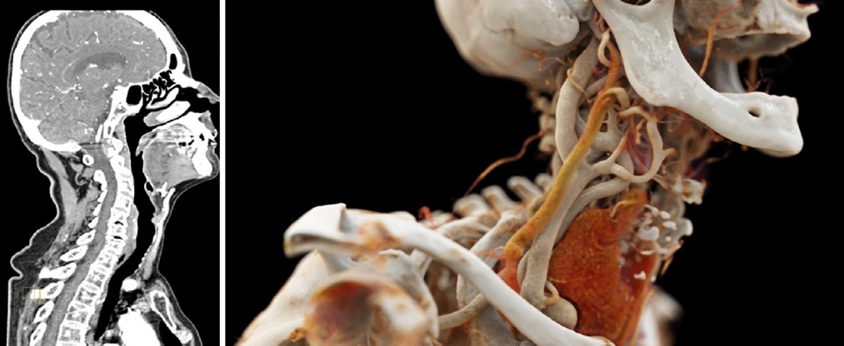

Figure 5. Original CT image (left) and realistic rendering (right)

Interpreting the tomographic data used in radiology and associated fields can be impacted by the environment that the data is viewed in. When performed on a traditional display, the ambient and direct lighting conditions found in radiology reading rooms, coupled with the radiologist’s positioning to the display, can result in diagnostic errors due to poorly calibrated displays and reflections. Virtual reality has the potential to diminish or remove these aspects of the environment. Sousa et al. developed VRRRRoom—Virtual Reality for Radiologist in the Reading Room—to examine the viability of using virtual reality to visualise and interact with tomographic data in a radiology context (Sousa et al., 2017). VRRRRoom immerses the radiologist in their data by visualising the tomographic data as a full 3D projection in front of the user. The system provides a natural user interface for manipulating this data, providing two-handed gestures to slice, adjust the brightness, and change the orientation of the 3D projection. A qualitative study of the system with radiology experts suggest that the immersion afforded by virtual reality reduced environmental distractions and conditions that would normally negatively affect readings. The study also suggests that the natural user interfaces are an efficient way for navigating tomographic data.

Another example of a multi-modal interactive system where radiologists can enter patient notes and explore MRI scans in a virtual environment was presented by Prange et al. (Prange et al., 2018). The system provides an immersive experience to doctors who can walk around in the virtual room and interact with the system via speech and hand gestures. The system includes a natural language-based dialog system, through which doctors can retrieve patient records and interrogate records in using natural language questions. The dialogue system has been integrated with a machine-learning based medical expert system that enables doctors to obtain information about therapies that may best suit a given patient from within the virtual environment.

Artificial intelligence and machine learning techniques have also been applied to interpret and enhance medical images. Comaniciu et al (2016) present an overview of recent advances in this area. For example, image segments corresponding to anatomical structures such as organs can be automatically identified, highlighted, and labelled in medical images. Figure 7 shows and example of overlaid anatomical landmarks and structures that were identified in medical images. Such methods can lead to improved quality of diagnosis, reduced uncertainty, and increased efficiency through comprehensive automated analysis, reporting, and comparison functions that combine medical images and test results with data sourced from specific patient history, similar cases and treatments.

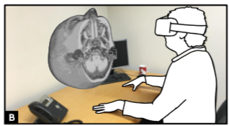

Figure 6 – VRRRRoom system

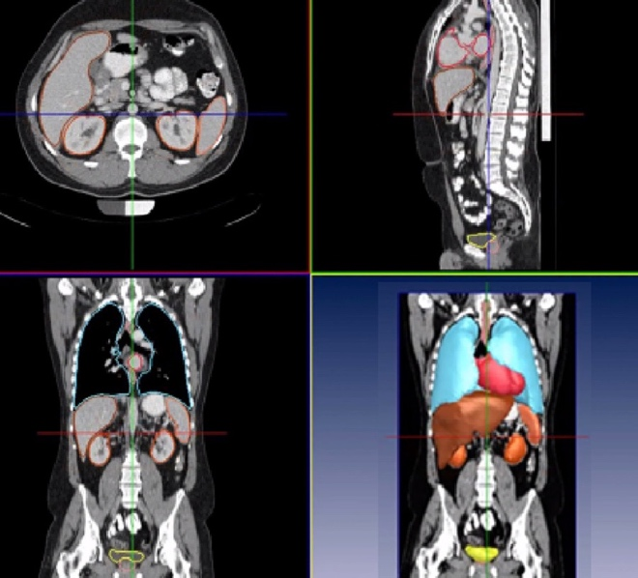

Figure 7.Whole Body CT Scan, identified organs and anatomical landmarks.

Precision medicine has benefitted from Artificial Intelligence methods. Model reconstruction techniques combined with machine learning methods can infer important landmarks, infer anatomy, and help synthesise precision surgical materials tailored to the specific conditions of a given patient. It is expected that three-dimensional models continuously reconstructed from medical sensors and images will be used to guide interventions in real-time in the future.

Computational models are increasingly being used to infer physiological conditions from medical imaging, thus replacing traditional invasive measurement techniques. For example, fractional flow rates characterizing the severity of coronary stenosis can be accurately inferred from CT images and fluid dynamic models. Moreover, quantitative models supported by machine learning technologies can be used to create patient-specific virtual models and predict outcomes under different scenarios. Virtual reality renderings of predicted treatment outcomes may assist doctors in comparing treatment options and identifying patient-specific optimal treatment plans. For example, Figure 8 shows the treatment effect on heart function as predicted by a personalized quantitative treatment model for a patient.

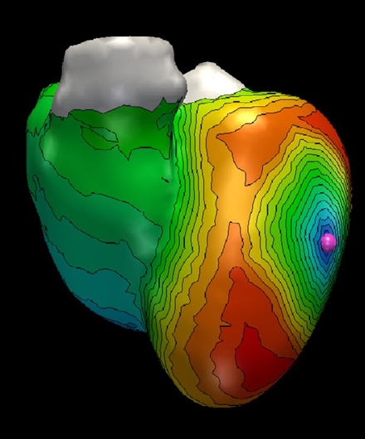

Figure 8. Effect of ventricular pacing on cardiac electrophysiology as predicted by a patient-specific model.

Beyond the volumetric data we commonly see in medical visualisation, there is a wealth of medical related information that does not naturally project into 3D space. The data visualisation community refers to this type of data as abstract data. Examples of abstract data in the medical domain are the results of biochemical analysis from blood tests or genomics data from DNA sequencing. These types of data can be high-dimensional. How these dimensions are projected into 2D- or 3D-space can directly influence the insights that can be derived from the information. ImAxes (Cordeil et al., 2017) demonstrates an immersive VR system for the visualisation of multi-dimensional abstract data. In ImAxes, the dimensions of the data are embodied as physical constructs within the space that can be grabbed and manipulated by the user. The physical positioning of dimensions relative to each other generates data visualisation such as scatterplots or parallel coordinate plots of the given dimensions. From this basic set of interactions, emergent visualisations can be developed that reveal clusters and relationships in the data—and potentially new insights that were not previously realised. In the medical context, a system such as ImAxes could support medical experts in exploring and understanding the relationships of their abstract data.

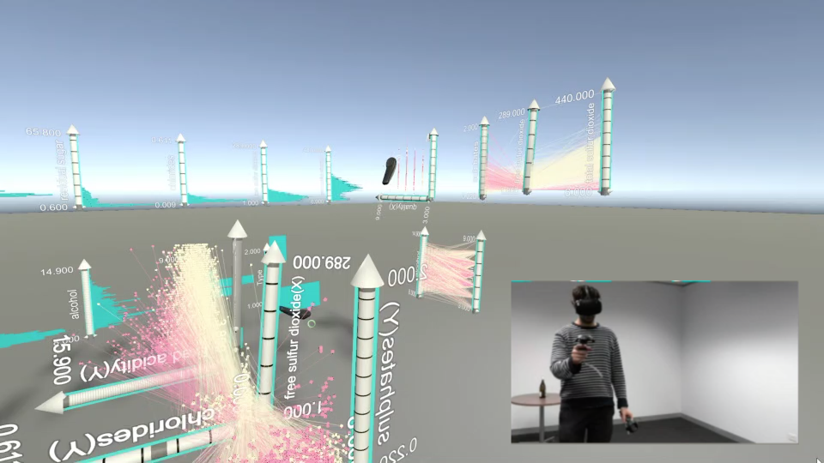

Figure 9: ImAxes used to explore a dataset containing chemical analyses. The user is able to freely construct visualisations around their body.

## Intervention and Clinical

Mixed reality provides the opportunity to bring detailed visualizations and present them in-situ with patients, medical tools and the operating environments. New techniques are being developed regularly that are exploiting the capabilities of mixed and virtual reality technologies to better support clinical practices, surgery, and training; they often provide an adjunct capability to a well-established practice.

Internal anatomy visualizations that allow users to see human organs with an immersive 3D environment or in-situ with a patient are well leveraged use cases for mixed reality systems. One example developed by Kasprzak et al. (2019) presented a mixed reality system to visualize echocardiography imagery in real-time with a mixed reality system. Figure 10 provides a depiction of the 3D holographic image at the users’ fingertips. The system converts echo data from a CT scan into a 3D stream of images presented through a Microsoft HoloLens. This process was used to view a patient's heart in a 3D environment rather than on a 2D screen. CT data is sent to a PC for 3D rendering and transmitted to the HoloLens for viewing. Hand gestures and voice commands are used for interaction without the need of any hand-held devices.

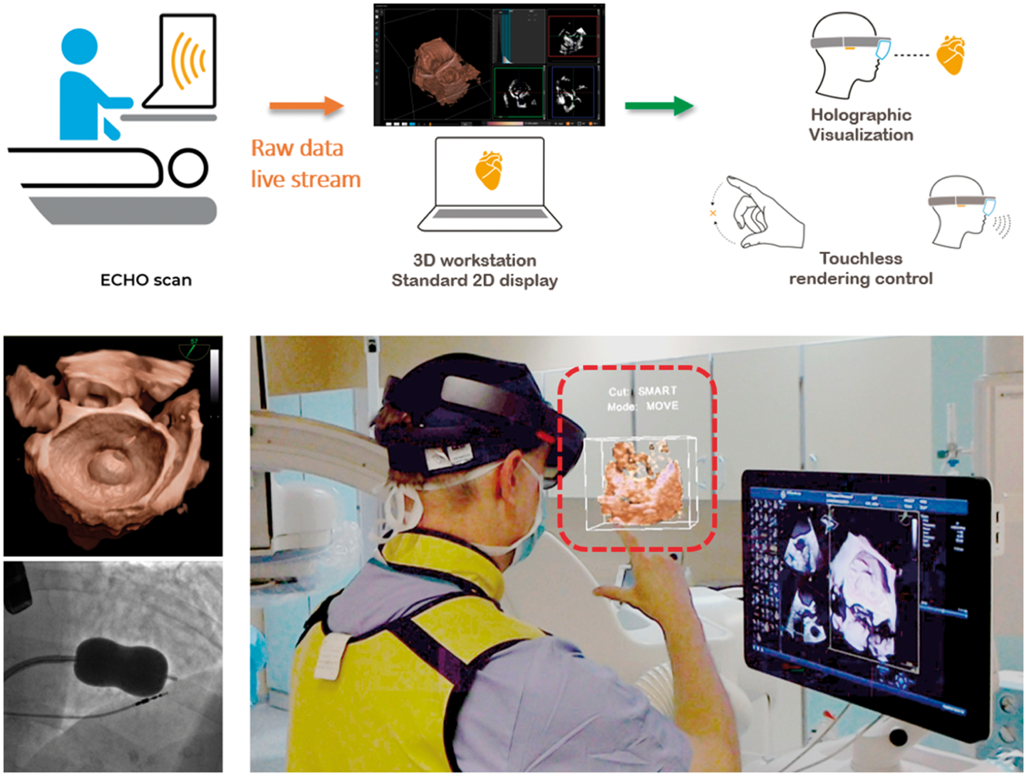

Figure 10 – Real-time echocardiography visualization presented with a mixed reality system

Overlaying holographic images directly onto the human body allows users to see a visualization of the internal anatomy inside the human body. A recent example of this technique was demonstrated by Pratt et al. (Pratt et al., 2018) which considered the effectiveness of using 3D overlays to aid with surgeries. These models were segmented in regions and then presented on a HoloLens capable of moving the objects around the real world overlaid on their patients (Figure 11). The calibration was done manually by having a human move the 3D object over the patient limb and position the patient's limb in the right spot. Six case studies indicated positive results with a reduction in operating time thus reducing the anaesthetic required and the patient's morbidity.

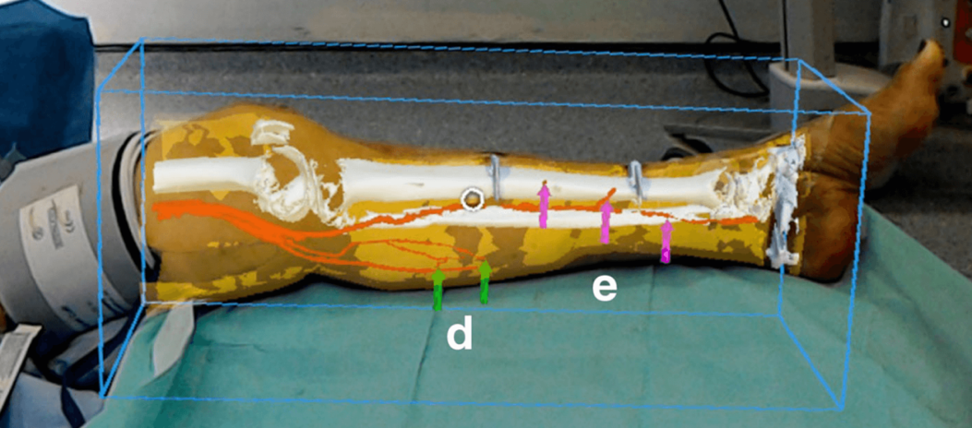

Figure 11 - MR Visualization of medial sural and posterior tibia perforators

In anatomic pathology, co-registration of digital radiographs with real world specimens has been explored to identify items of interest. Hanna Hanna et al. (2018) conducted a study with pathologists' assistants to overlay virtual radiographs onto corresponding gross specimens to identify the location of a biopsy clip or lesions. Voice and hand gestures were employed to scale and position the radiograph in place. Results of a usability study found that users were able to identify the precise location of a biopsy clip faster than using conventional methods. In addition, several other use cases were explored. Live streaming (audio and visual) and bidirectional annotation were employed via Microsoft’s Skype Collaboration platform to facilitate a remote pathologist guiding a pathology trainee/assistant through an autopsy procedure or to obtain tissue sections. The HoloLens was used to view reconstructed 3D images of cellular and subcellular structures and to view and manipulate (i.e. resize, rotate, etc.) 3D gross specimens.

Using AR for needle guidance has received attention in the research community. Agten et al. (2018) found that it possible to match the results of conventional guidance methods to that of their HoloLens prototype while using a lumbar vertebrae phantom. The HoloLens display showed a 3D model of the lumbar vertebrae as well as a blue target for the needle insertion. Augmented reality needle guidance techniques have also been investigated for transperineal prostate procedures (for example, biopsy and ablation). Li et al. (Li et al., 2019) developed a needle guidance application for use with a smartphone or smart glasses. Data derived from pre-procedural MRI/CT images was used to display anatomic information, the planned needle trajectory, and the target lesion. The information was designed to be overlaid onto the patient and tracked using an image marker (along with five fiducial markers placed on the back of the image marker) attached to the patient’s perineum. Smartphone functionality allowed the user to select a target, define the needle plan and view surrounding anatomy in 3D. In usability studies using a prostate phantom, participants were asked to insert a biopsy needle to reach a target using either a smartphone (iPhone) or smart-glasses (ODG R-7) to present the information. The needle end and planned needle path were displayed for each target. Results of the study indicating for needle placement smartphone guidance had a trend towards less errors compared to the smart glasses.

The Vivo Light Vein Finder is an example of a commercially available spatial augmented reality device used for vascular imaging. The device provides a real-time visualization of structures inside the body by projecting images directly onto the skin. This visualization supports finding accurate location for injections, which was proven to be very effective with less experienced nursing students who demonstrated improved time and efficiency (Fukuroku, 2016). Veins were located by projecting near infrared light onto the human body, where the haemoglobin in the blood absorbed some of this light and allowing veins and vascular structures to be identified. This information was then augmented with projected light revealing the underlying structures on the skin's surface. This method was demonstrated to work on over 90% of patients depending on their age, health and race (Chiao, 2013).

García-Vázquez et al. (2018) investigated a new approach to device navigation for endovascular aortic repair. Their approach used an electromagnetic tracking system to find the position of the catheter throughout the body using three or more exterior landmarks that also served as calibration markers for the HoloLens. This enabled the user to see the approximate location and movement of the catheter tip inside the patient through the HoloLens as shown in Figure 12. This approach used in conjunction with conventional practices are great examples of the increase in efficiency that Mixed Reality could bring to medical intervention.

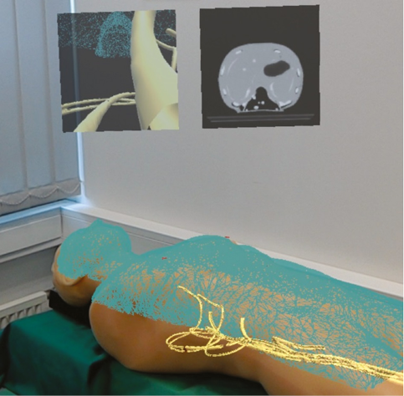

Figure 12 - Endovascular aortic repair

Projected overlays have also been employed with the aim of assisting in radiofrequency ablation (RFA) of liver tumours. Si et al. (Si et al, 2018) investigated moving the needle in relation to MRI data that was overlaid on an object. The MRI data was represented as a holographic overlay on a patient (in the case of this research, a physical abdominal phantom). The hologram of the MRI data was overlaid over the phantom by using a HoloLens and an NDI tracking system. The system used tracking markers placed on the phantom to gain an accurate estimation of the physical position. Three-dimensional object recognition technology was used to track the position of the needle and show the user where the needle was located within the object. Results of a subsequent user study suggested that the mixed reality approach benefitted surgeons through simplicity and is more efficient and precise when compared with the un-aided approach.

Augmented reality has been applied to orthopaedics. An example is the use of augmented reality to assist and guide hole drilling along the axis of the femoral neck for hip resurfacing (Liu et al., 2018). Liu et al. employed a depth camera mounted on a robotic arm, a tracked surgical drill, and a HoloLens to guide the drilling of a hole on a femur phantom. A red arrow indicating the entry point and drilling direction for the guide hole was shown in-situ, overlaid onto the surgeon’s view via a HoloLens (seen in Figure 13). The arrowhead and shaft turned green when the position and orientation were accurate indicating to the surgeon to proceed with drilling (illustrated in Figure 13) an estimate of the femur pose by processing a scanned 3D model of the femur coupled with depth data (obtained by a depth camera in the form of a 3D point cloud). Accurate femur pose was obtained via an iterative closest point algorithm which runs during the procedure. In addition, two markers were used in order to align the HoloLens with the robot and camera, and a cube marker (depicted in Figure 14) was attached to the surgical drill so that it could be tracked by the HoloLens. Results obtained from usability studies revealed that position and direction mean errors of 2 mm and 2 degrees respectively were achieved when compared against the pre-operative plan.

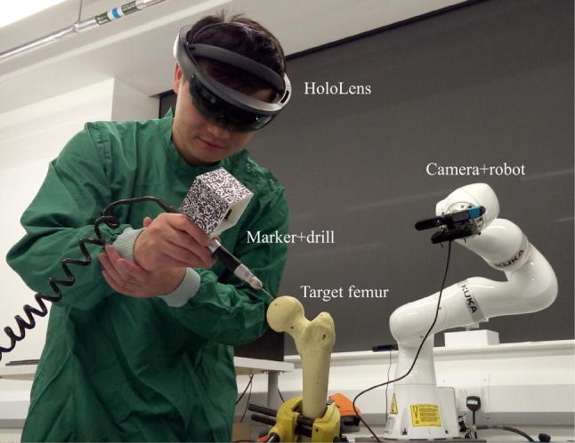

Figure 13 - Cube marker attached to surgical drill to assist with HoloLens tracking.

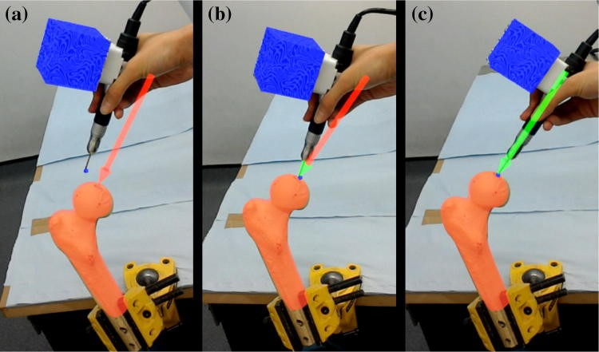

Figure 14 - Surgeon’s view via HoloLens. a) Red arrow depicting entry point and drilling direction; b) Green arrow indicating correct position; c) Green arrow and shaft depicted to proceed with drilling.

## Interactions and Gestures

Interactions in mixed reality brings many new challenges and opportunities to the users and developers alike. The tracking of tools, recognition of hand gestures, voice commands, and even gaze gestures are novel options for interaction and enable opportunities to develop applications for nearly all health professionals. Although research in this field has delivered tremendous advances in recent years, many challenges related to accuracy, reliability, technology, and integration into clinical contexts remain the subject of ongoing research activity. Currently, systems have been either in the form of prototypes that have been tested in controlled environments, or have been employed for training of medical professionals. Deployments of advanced AR and MR systems in the routine clinical context with direct involvement of patients are still the exception, not the rule.

For many surgical procedures, it may not be feasible for surgeons to use hand gestures to manipulate or interact with digital information. For example, given the nature of vascular interventions, surgeons must have both hands engaged in the surgical task. Although augmented reality guidance systems have been developed, they predominantly rely on hand gestures for navigation and control. Researchers have explored interaction techniques that may address this limitation. For example, Grinshpoon (2018) developed a system that employed voice commands and gaze gestures for interaction. In this system, the user could move, rotate, enlarge and scale digital content by looking at specific points in the environment.

Scrub nurses working in a high-stress surgical environment are governed by many strict rules about sanitization. In such an environment using hand-based interaction techniques and even voice commands may be unsuitable as they may be distracting for the surgeon. Unger (2019) developed a gaze-based gesture control interface that may be suitable for this environment. The system supported two main tasks: users could adjust the lighting of the surgical room by repeatedly gazing at specific sections of the room, and users could receive information about surgical items by looking at them. 2D barcodes were placed next to the surgical equipment to facilitate object recognition. This system proved the viability of voice- and gesture-less control interfaces, and participants in a trial performed well and indicated their satisfaction with the proposed interaction technique.

Some tasks in the field of medical imaging require medical professionals to view live medical data while the patient is still being scanned. Wearing a headset for this type of research can be impractical due to the magnetic nature of the machines and the lack physical of space within the gantry. The current conventional methods use 2D monitors located outside of the gantry require good situational awareness and hand eye coordination from the user. Mewes (Mewes, 2018) successfully set out to find a more convenient way to represent medical data for professionals working within a scanner. Several mirrors were used move a projected user interface over the top of the patient inside the scanner. This system tracked needles using 3D object recognition and had two different user interfaces: a 2D interface and a 3D interface. The 2D interface aimed to help the surgeon find a suitable point of entry by displaying yellow and red arrows that would guide the surgeon towards the point of insertion. A bar was shown to let the surgeon know how much further inside of the patient the needle needed to go. The 3D display showed an approximate insertion point, its target area, and how far the needle had gone within the patient’s. The distance of the needle to the entry point was displayed as a line segment connecting the needle to its entry point. Both user interfaces proved to be more beneficial than the current methods of performing these needle insertions within a scanner as reported by both inexperienced and experienced professionals.

In VR systems, realistic interactions with virtual objects and visualizations presents an additional challenge. Controllers and gestures can provide interactions, however they lack the haptic feedback provided through direct touch. Providing the ability to directly touch, feel or hold elements of the virtual environment requires a physical counterpart in the real world. Haptic technologies aim to address this issue through active devices such as haptic gloves[1] haptic controllers (Choi, Whitmire, 2018, Benko, 2016) and robotic systems (E. Vonach et al., 2017, Whitmire, 2018). (Alternatively, passive haptics or simple static objects can approximate virtual objects and have been shown to enhance virtual experiences (Insko, 2001). Passive haptics can be further extended through illusions such as space warping (Kohli, 2010) and haptic retargeting (Azmandian, 2016) which leverage the dominance of visual perception over haptic perception and proprioception. These illusions enable realistic interaction with a virtual object that is dynamic or more complex than the physical passive haptic that approximates it. These techniques could be applied in medical visualizations to provide direct touch interaction and exploration methods. Spillman et al. have applied space warping to an arthroscopy surgical simulator for medical training to enhance the detail provided by a passive haptic (J. Spillmann, 2013). Virtual models from a variety of patients can be mapped onto a single physical model, enabling the user to explore and operate on the models with realistic feedback.

## Education

Virtual and augmented reality have become increasingly popular in medical education, as technology enables students to interact with virtual representations of specimen in ways that would be difficult to achieve using the actual physical objects. In this context, virtual and augmented reality technologies enable instructors to add explanatory material and demonstrate varying physical conditions, whereas students can easily focus on specific elements of the subject under study by hiding unwanted parts and use zoom and colour to highlight parts of interest. Additionally, teaching using virtual specimen scales to a large audience whereas teaching using physical objects can be limited by the number, location, and physical condition of the available specimen.

Balian et al. (Balian et al., 2019) investigated the use of augmented reality for training health care providers in providing cardiopulmonary resuscitation (CPR). To this end, the authors employed the use of a HoloLens to provide audio and visual feedback for participants performing CPR on a training manikin. Quantitative chest compression data such as rate, depth and recoil were recorded as hands-only CPR was performed on the manikin. The data was used to provide visual feedback by means of blood flow to vital organs and is depicted in a circulatory system placed in front of the user via HoloLens head-worn display. Depending on the quality of the chest compressions, blood flow to the vital organs is shown to either improve or deteriorate. An audible heartbeat at 110 bpm was provided if the user performs chest compressions outside of the guideline range of 100-120 cpm. In addition, a CPR quality score was displayed at the end of the session. Results from a usability study indicated that the system was a beneficial training tool that facilitates good quality CPR and was well received by participants (82% perceived the experience as realistic, 94% of participants were willing to use the application in future training and 98% acknowledged that the visualizations were helpful for training).

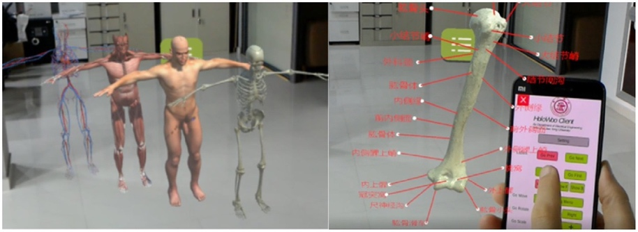

Figure 15.User interface for interacting with the 3D model. Left: whole-body menu. Right: smartphone-based interface for interaction with the model.

Karambakhsh et al. (Karambakhsh et al., 2019) presented an application for anatomy education that utilises virtual reality techniques for presentation of anatomy models and leveraged augmented reality and machine learning for controlling the interaction with the specimen. The system acquires models using 3D scanning techniques, presented the model using augmented reality techniques, and provided an interface for instructors to annotate the model. The anatomy models are acquired by scanning the physical object using an infrared camera that also senses the distance to the object. Multiple partial scans are then aligned and merged into a complete mesh model based on corresponding key points featuring in multiple models. Instructors subsequently post-process the model and label key elements in the model using a dedicated user interface application Figure 15 (right). Students explored the resulting anatomy model while wearing a HoloLens, which displays the model from the correct viewpoint, and they control the system using hand gestures, which are tracked using the camera built into the HoloLens. Supported control gestures include Pan, Pinch, Zoom, Fist, and Tap, which the system can learn from examples using Deep Convolutional Neural Networks. This approach was shown to provide superior gesture detection accuracy than previous approaches that relied on geometric properties and support vector machines for gesture classification.

Applications of MR technologies for education can be found in the field of Dentistry (Huang et al., 2018). For example, student dentists can train to perform tasks, such as cavity and crown preparation, on physical and virtual models. In the educational settings, systems exist where virtual tutors monitor the students and assess multiple factors such as ergonomic posture and quality of the task outcome and provide formative feedback. For example, Su Yin et al. present a simulator for endodontic surgery that provides formative feedback to dental students about the quality of the resulting drill hole (Yin et al., 2018). Students perform drilling on a virtual 3D model of the tooth and receive feedback about their physical movement (speed, force) and their performance outcome in terms of the deviation from the optimal result. Figure 16 shows a view indicating areas where deviations from the optimal results have occurred. The detailed results are additionally presented in a standard scoring approach that is commonly used in dentistry education. This approach was shown to provide scoring results that are consistent with scoring by human experts.

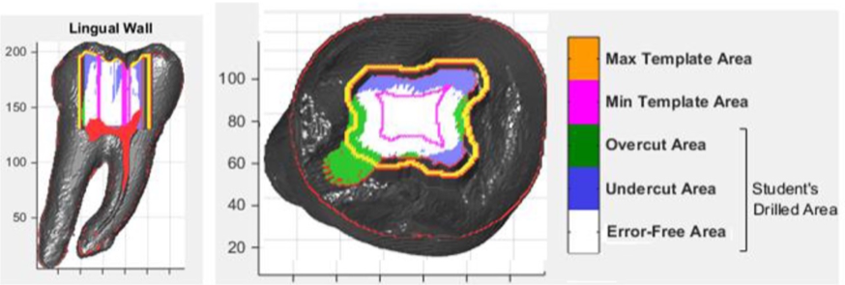

Figure 16 – Simulation performance outcome diagrams including undercut and overcut areas

# Conclusion

The exciting possibilities afforded by mixed reality systems have been foreseen by early visionaries such as Ivan Sutherland who developed their own hardware to uncover a new presentation method for computer generated information in the early 1960’s. Now almost 60 years later we are seeing a rapid acceleration of hardware technologies that can deliver compelling real-time visual information that is accessible and affordable. Mixed and virtual reality technologies are now being considered in more depth for a diverse set of applications and often are providing new supporting roles with well-established practices in medical domains.

This chapter described the core presentation methods for mixed and virtual reality systems that have found applications in the medical field today and briefly explored the current limitations in terms of calibration and the current research methods that are aiming to reduce or overcome these challenges. Exemplars covering a wide spectrum of tasks were presented to demonstrate the breadth of visualizations and non-traditional interaction techniques that are being employed to enhance medical procedures from in-situ anatomy visualizations, abstract data representations and interaction methods.

# References

AGTEN, C. A., DENNLER, C., ROSSKOPF, A. B., JABERG, L., PFIRRMANN, C. W. A., & FARSHAD, M. 2018. Augmented Reality-Guided Lumbar Facet Joint Injections. Investigative Radiology. 53**,** 495-498.

AZMANDIAN, M. A. H., MARK AND BENKO, HRVOJE AND OFEK, EYAL AND WILSON, ANDREW D. 2016. Haptic Retargeting: Dynamic Repurposing of Passive Haptics for Enhanced Virtual Reality Experiences. *Proceedings of the 2016 CHI Conference on Human Factors in Computing Systems***,** 1968-1979.

BALIAN, S., MCGOVERN, S. K., ABELLA, B. S., BLEWER, A. L. & LEARY, M. 2019. Feasibility of an augmented reality cardiopulmonary resuscitation training system for health care providers. *Heliyon,* 5**,** e02205.

BENKO, H. A. H., CHRISTIAN AND SINCLAIR, MIKE AND OFEK, EYAL 2016. NormalTouch and TextureTouch: High-fidelity 3D Haptic Shape Rendering on Handheld Virtual Reality Controllers. *Proceedings of the 29th Annual Symposium on User Interface Software and Technology***,** 717-728.

CHIAO, F. B., RESTA-FLARER, F., LESSER, J., NG, J., GANZ, A., PINO-LUEY, D., WITEK, B 2013. Vein visualization: patient characteristic factors and efficacy of a new infrared vein finder technology. *British Journal of Anaesthesia,* 110**,** 966-971.

CHOI, I. A. O., EYAL AND BENKO, HRVOJE AND SINCLAIR, MIKE AND HOLZ, CHRISTIAN CLAW: A Multifunctional Handheld Haptic Controller for Grasping, Touching, and Triggering in Virtual Reality. *Proceedings of the 2018 CHI Conference on Human Factors in Computing Systems,* 654.

COMANICIU, D., ENGEL, K., GEORGESCU, B. & MANSI, T. 2016. Shaping the future through innovations: From medical imaging to precision medicine. *Medical Image Analysis,* 33**,** 19-26.

CORDEIL, M., CUNNINGHAM, A., DWYER, T., THOMAS, B. H. & MARRIOTT, K. 2017. ImAxes: Immersive Axes as Embodied Affordances for Interactive Multivariate Data Visualisation. *Uist'17: Proceedings of the 30th Annual Acm Symposium on User Interface Software and Technology***,** 71-83.

CUTOLO, F., FRESCHI, C., MASCIOLI, S., PARCHI, P., FERRARI, M., & FERRARI, V. 2016. Robust and Accurate Algorithm for Wearable Stereoscopic Augmented Reality with Three Indistinguishable Markers. *Electronics,* 5**,** 59.

E. VONACH, C. GATTERER & KAUFMANN, H. 2017. VRRobot: Robot actuated props in an infinite virtual environment. *2017 IEEE Virtual Reality (VR)***,** 74-83.

GARCIA-VAZQUEZ, V., VON HAXTHAUSEN, F., JACKLE, S., SCHUMANN, C., KUHLEMANN, I., BOUCHAGIAR, J., HOFER, A. C., MATYSIAK, F., HUTTMANN, G., GOLTZ, J. P., KLEEMANN, M., ERNST, F. & HORN, M. 2018. Navigation and visualisation with HoloLens in endovascular aortic repair. *Innovative Surgical Sciences,* 3**,** 167-+.

HANNA, M. G., AHMED, I., NINE, J., PRAJAPATI, S. & PANTANOWITZ, L. 2018. Augmented Reality Technology Using Microsoft HoloLens in Anatomic Pathology. *Archives of Pathology & Laboratory Medicine,* 142**,** 638-644.

HOE, Z-Y., LEE, I.-J., CHEN, C.-H., & CHANG, K.-P. 2019. Using an augmented reality-based training system to promote spatial visualization ability for the elderly. *Universal Access in the Information Society*, *18*(2), 327–342.

HUANG, T. K., YANG, C. H., HSIEH, Y. H., WANG, J. C. & HUNG, C. C. 2018. Augmented reality (AR) and virtual reality (VR) applied in dentistry. *Kaohsiung J Med Sci,* 34**,** 243-248.

INSKO, B. E. 2001. Passive Haptics Significantly Enhances Virtual Environments. *PhD Thesis*.

J. SPILLMANN, S. T. A. M. H. 2013. Adaptive Space Warping to Enhance Passive Haptics in an Arthroscopy Surgical Simulator. *in IEEE Transactions on Visualization and Computer Graphics,* 19.

KARAMBAKHSH, A., KAMEL, A., SHENG, B., LI, P., YANG, P. & FENG, D. D. 2019. Deep gesture interaction for augmented anatomy learning. *International Journal of Information Management,* 45**,** 328-336.

KASPRZAK, J. D., PAWLOWSKI, J., PERUGA, J. Z., KAMINSKI, J. & LIPIEC, P. 2019. First-in-man experience with real-time holographic mixed reality display of three-dimensional echocardiography during structural intervention: balloon mitral commissurotomy. *Eur Heart J*.

KNODEL, M. M., LEMKE, B., LAMPE, M., HOFFER, M., GILLMANN, C., UDER, M. & BÄUERLE, T. 2018. Virtual reality in advanced medical immersive imaging: a workflow for introducing virtual reality as a supporting tool in medical imaging. *Computing and Visualization in Science,* 18**,** 203-212.

KOHLI, L. 2010. Redirected touching: Warping space to remap passive haptics. *2010 IEEE Symposium on 3D User Interfaces***,** 129-130.

LI, M., XU, S., MAZILU, D., TURKBEY, B. & WOOD, B. J. Smartglasses/smartphone needle guidance AR system for transperineal prostate procedures. SPIE Medical Imaging, March 2019. SPIE.

LIU, H., AUVINET, E., GILES, J. & RODRIGUEZ Y BAENA, F. 2018. Augmented Reality Based Navigation for Computer Assisted Hip Resurfacing: A Proof of Concept Study. *Annals of Biomedical Engineering,* 46**,** 1595-1605.

MEWES, A., HEINRICH, F., HENSEN, B., WACKER, F., LAWONN, K., & HANSEN, C. 2018. Concepts for augmented reality visualisation to support needle guidance inside the MRI. *Healthcare Technology Letters,* 5**,** 172-176.

PRANGE, A., BARZ, M. & SONNTAG, D. 2018. Medical 3D Images in Multimodal Virtual Reality. *Companion of the 23rd International Conference on Intelligent User Interfaces (Iui'18)*.

PRATT, P., IVES, M., LAWTON, G., SIMMONS, J., RADEV, N., SPYROPOULOU, L. & AMIRAS, D. 2018. Through the HoloLens looking glass: augmented reality for extremity reconstruction surgery using 3D vascular models with perforating vessels. *Eur Radiol Exp,* 2**,** 2.

SOUSA, M., MENDES, D., PAULO, S., MATELA, N., JORGE, J. & LOPES, D. S. 2017. VRRRRoom: Virtual Reality for Radiologists in the Reading Room. *Proceedings of the 2017 Acm Sigchi Conference on Human Factors in Computing Systems (Chi'17)***,** 4057-4062.

SUTHERLAND, I. E. 1968. A head-mounted three dimensional display. *Proceedings of AFIPS 68***,** 757-764.

WHITMIRE, E. A. B., HRVOJE AND HOLZ, CHRISTIAN AND OFEK, EYAL AND SINCLAIR, MIKE 2018. Haptic Revolver: Touch, Shear, Texture, and Shape Rendering on a Reconfigurable Virtual Reality Controller. *Proceedings of the 2018 CHI Conference on Human Factors in Computing Systems,* 86.

YIN, M. S., HADDAWY, P., SUEBNUKARN, S. & RHIENMORA, P. 2018. Automated outcome scoring in a virtual reality simulator for endodontic surgery. *Computer Methods and Programs in Biomedicine,* 153**,** 53-59.

1. https://haptx.com/